# ***Ahsanullah University of Science & Technology***

Department of Computer Science & Engineering



[Obstacle Avoiding Robot]

CSE 3216

Microcontroller Based System Design lab

**Submitted By :**

Rafiqul Islam 16.01.04.011

Shariqa Trina 16.01.04.014

Gazi Mahedee Hasan 16.01.04.016

Saiful Islam Sakib 16.01.04.017

Date of Submission: **12 March, 2019**

**Introduction:**

An Obstacle Avoidance Robot is an intelligent robot, which can automatically sense and overcome obstacles on its path. It contains of a Microcontroller to process the data, and Ultrasonic sensors to detect the obstacles on its path. Obstacle avoidance is one of the most important aspects of mobile robotics.

**Purpose:**

The primary purpose of the project is to create a robot which can make decision itself about movement on different terrain. The functionalities of the robot can be extended as needed. It can be used to collect information about it’s surroundings without a human guide.

**Equipment:**

**Arduino**

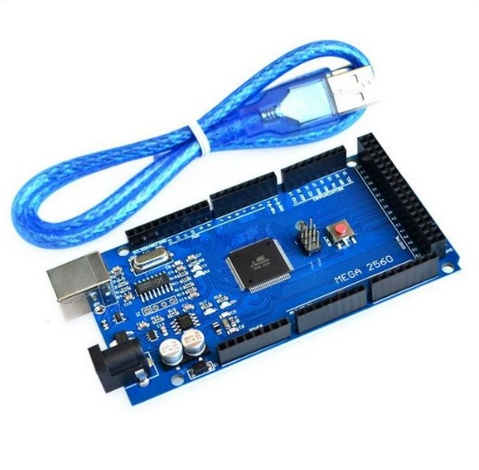

**Gear Motor**

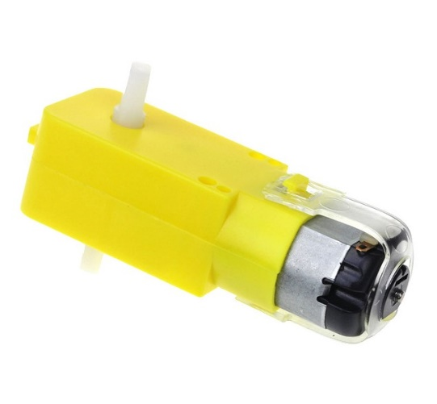

**Motor Driver**

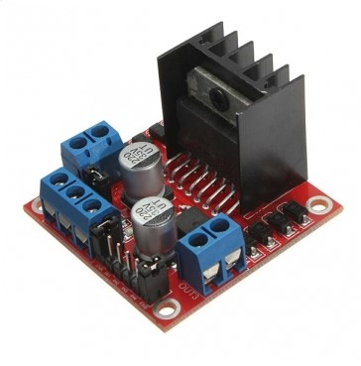

**Servo Motor**

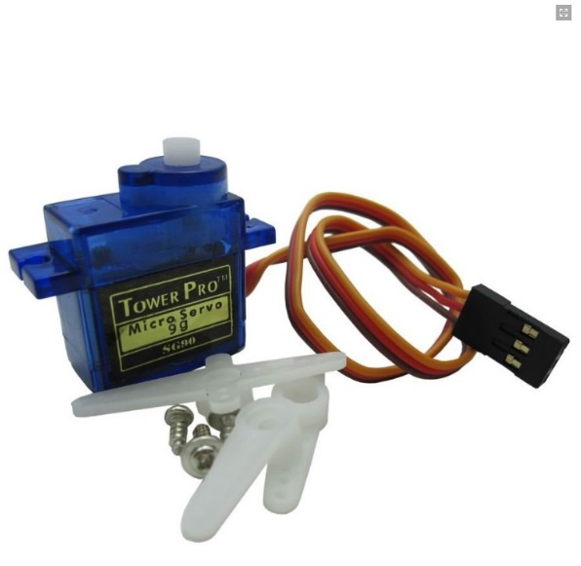

**Ultrasonic Sensor**

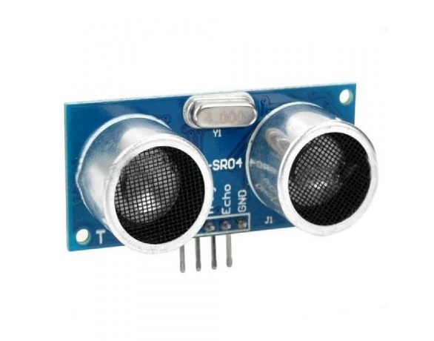

**Circuit Diagram:**

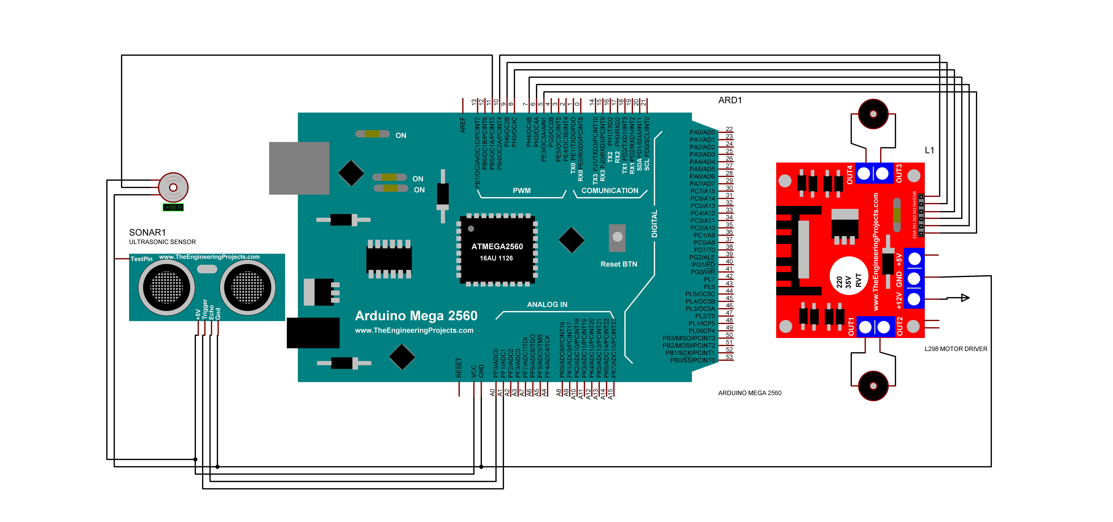

**Features:**

* Detecting obstacle
* Avoiding Collision
* Move where no obstacle

**An Image of Similar Robot:**

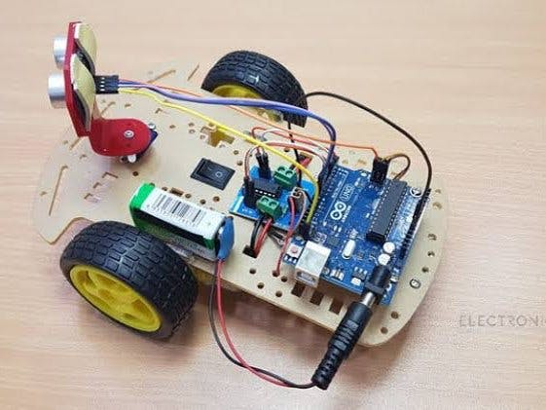

**Conclusion:**

Obstacle avoidance is one of the most important aspects of mobile robotics. Without it robot movement would be very restrictive and fragile. From a learner’s point of view it helped us a lot to learn about the world of robotics.